Deep Reinforcement Learning for Autonomous Rocket Landing Control Using DQN Algorithm

Handoyo

Department of Computer Engineering, Faculty of Engineering, Diponegoro University, Semarang, Indonesia

*E-mail:* [*Handoyo@students.undip.ac.id*](mailto:Handoyo@students.undip.ac.id)[12pt]

# Abstract

This paper presents an implementation of Deep Q-Network (DQN)-based reinforcement learning for autonomous rocket landing control. A 2D simulation environment (SimpleRock- etEnv) was developed to allow the agent to learn optimal thrust control through reward-based feedback. The reward function is specifically designed to encourage safe landings on a moving target, considering position, velocity, and orientation of the rocket. Experimental results demonstrate that the reward-shaped DQN model successfully achieves stable landings with positive average rewards after 500 training episodes. These results validate the effectiveness of the custom reward design and neural network architecture in teaching safe and efficient rocket control behavior.

*Keywords: Deep Q-Network, reinforcement learning, rocket simulation, reward shaping, au- tonomous landing*

# Introduction

The development of autonomous control sys- tems has become increasingly essential in the context of aerospace and robotics. One of the most challenging problems is the autonomous vertical rocket landing, which involves stabi- lizing and controlling a rocket to safely land on a fixed target under dynamic conditions.

This research implements a Deep Q- Network (DQN)-based reinforcement learn- ing approach to train a rocket to land au- tonomously using a simulated environment (SimpleRocketEnv). The motivation of this study is to apply reinforcement learning for continuous control in aerospace-like en- vironments, evaluate the influence of neural network architecture, replay buffer size, and

reward shaping on landing performance, and demonstrate that a DQN agent can learn opti- mal control behavior without explicit dynam- ics modeling.

# Environment Description

The simulation environment, SimpleRocketEnv, replicates a simplified rocket landing task fol- lowing the OpenAI Gym interface.

**Observation Space:** [*x, y, vx, vy, θ, ω*], where *x, y* are positions, *vx, vy* are linear velocities, and *θ*, *ω* represent angular position and veloc- ity.

**Action Space:** Discrete thrust commands: 0 = no thrust, 1 = left thrust, 2 = right thrust, 3 = main thrust.

**Reward Function:** Provides negative rewards

for deviation from target and high velocity, and positive rewards when the rocket lands smoothly.

## Termination Conditions:

* Rocket leaves simulation bounds,
* Crash (velocity above threshold),
* Successful landing near target.

This environment effectively models a 2D

rocket control problem suitable for reinforce- ment learning.

# Methods

## Deep Q-Network (DQN)

The DQN algorithm [1] extends Q-learning us- ing a deep neural network as an approximator of the action-value function:

*Q*(*s, a*; *θ*) = E *rt* + *γ* max *Q*(*s′, a′*; *θ−*) (1)

h i

*a′*

Two neural networks are used in the train- ing process: the policy network *Qθ* and the target network *Qθ−* , which is periodically up-

dated to improve the stability of the training. The loss function minimized during learning is defined as:

*L*(*θ*) = E *′* h *r* + *γ* max *Q*(*s′, a′*; *θ−*) − *Q*(*s, a*; *θ*) 2i (2)

## Replay Buffer

(*s,a,r,s* )

*a′*

stabilizes learning.

A replay buffer stores transitions (*s, a, r, s′, done*) up to 100,000–200,000 steps. Random sampling from this buffer prevents correlations between consecutive states and

## Neural Network Architecture

Four DQN versions were evaluated, as sum- marized in Table 1.

Table 1: Comparison of Neural Network Architectures.

|  |  |  |  |  |
| --- | --- | --- | --- | --- |
| **Version** | **Layers** | **Neurons** | **Activation** | **Feature** |
| V1 (Basic) | 2 | 128 | ReLU | Baseline model |
| V2 (Improved) | 2 | 256 | ReLU | Enhanced feature extraction |
| V3 (Optimized) | 3 | 512–256–128 | ReLU | Smooth convergence |
| V4 (Reward Shaped) | 3 | 512–256–128 | ReLU | Custom reward |

## Implementation Notes: Manual DQN in PyTorch

The DQN agent was implemented manually using PyTorch 2.0. Key components include:

* **Replay Buffer:** Stores past transitions (*s, a, r, s′,* done) up to 200,000 steps. Random sampling breaks temporal cor-

relation.

* **Policy and Target Networks:** Two neu- ral networks with architectures specified in Table 1. The target network is updated softly using *θ−* ← *τθ* + (1 − *τ* )*θ−*.
* **Bellman Update:** Q-values are updated using

*Q*(*s, a*) ← *Q*(*s, a*) + *α r* + *γ* max *Q*(*s′, a′*; *θ−*) − *Q*(*s, a*)

*a′*

* + implemented via MSE loss and Adam optimizer.
  + **Exploration Strategy:** *ϵ*-greedy pol- icy with exponential decay: *ϵt* =

This explicit implementation ensures full control over training, enabling comparison be- tween DQN variants and hyperparameter tun- ing.

max(*ϵ*min*, ϵ*0 × decay*t/k*).

* + **Gradient Clipping:** Gradients clipped within ±1.0 to prevent exploding gradi- ents.

## Reward Shaping

To accelerate convergence, the reward was modified as follows:

*R′* = *R* − 0*.*05(|*x*| + |*y*|) − 0*.*1(|*vx*| + |*vy*|) + 0*.*5(1 − (|*θ*| + |*ω*|)) + *bonus* (3) This design penalizes distance and velocity errors while rewarding stability and upright land- ings.

## Pseudocode

if landing_successful: # |vy| < 1.2, |vx| < 0.8, |x - xt| < 0.5 reward = +500

elif crash_or_unstable: reward = -200

else:

reward = -abs(x - xt) # horizontal distance penalty

-0.3 * abs(vx) # horizontal velocity penalty

-0.5 * abs(vy) # vertical velocity penalty

-0.1 * abs(y) # altitude penalty

-0.05 # per-step small penalty

This reward structure penalizes deviations and high velocities while encouraging energy- efficient, upright landings. The step-wise

penalty ensures faster convergence by incen- tivizing the agent to reach the target in fewer steps.

## Hyperparameters

Table 2: Training Hyperparameters.

## Parameter Value/Description

Learning Rate 1 × 10*−*4 – 3 × 10*−*4 (Adam optimizer)

Discount Factor (*γ*) 0.995

Replay Start 5000 steps before training

Batch Size 128

Epsilon Decay 0.995

Target Update Interval Every 10 episodes Soft Update (*τ* ) 0.01

# Results and Discussion

## Neural Network Architecture

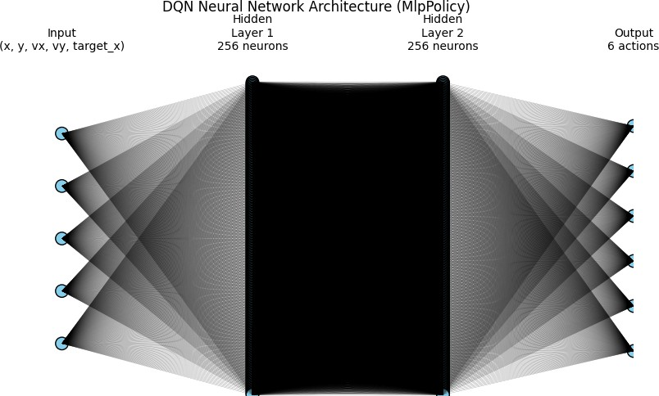

Figure 1: Neural network architecture used in the Deep Q-Network (DQN) agent for the rocket landing environment. The input layer receives the state vector {*x, y, vx, vy,* target*x*}, represent- ing the rocket’s current position, velocity components, and horizontal target position. This information is processed through two fully-connected hidden layers, each consisting of 256 neurons with non-linear activation functions (ReLU). These hidden layers allow the network

to capture complex nonlinear relationships between the rocket’s dynamics and control actions. The output layer produces 6 Q-values corresponding to the discrete action space (e.g., thrust up, left, right, rotate, etc.), representing the expected cumulative reward for each possible ac- tion given the current state. This architecture aligns with the MlpPolicy configuration from Stable-Baselines3, balancing model capacity and training stability.

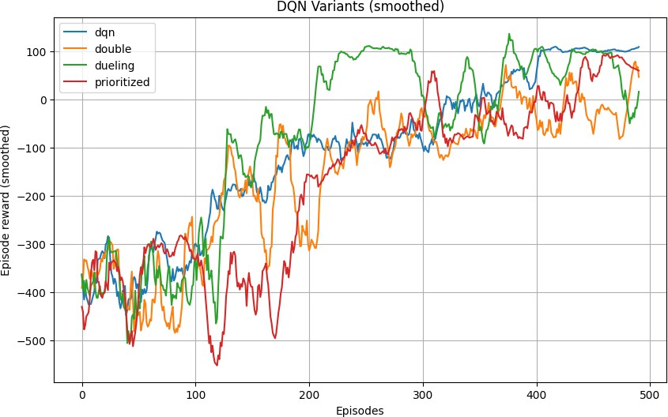

Figure 2: Learning curve showing the total reward per episode during training. The X-axis represents training episodes (0–500), while the Y-axis represents cumulative episode rewards. A moving average over 50 episodes is applied to smooth fluctuations and highlight convergence trends, demonstrating how the DQN progressively improves its landing performance as it learns to minimize velocity and position error.

## Learning Performance

At the beginning of training, the agent pro- duced highly negative rewards (-2000 to -700) due to frequent crashes. Over 500 episodes, the average reward increased significantly, in- dicating that the rocket gradually learned to stabilize and reduce its descent velocity.

## Comparison Between Versions

Table 3 presents the performance comparison among four Deep Q-Learning model variants. Each version differs in network architecture or reward shaping, allowing us to analyze their learning stability and efficiency.

Table 3: Comparison of DQN Variants on Rocket Landing Task

|  |  |  |  |
| --- | --- | --- | --- |
| **Model Variant** | **Mean Reward** | **Std. Dev. Reward** | **Final Reward** |
| DQN | −110*.*64 | 182*.*92 | 118*.*53 |
| Double DQN | −158*.*81 | 196*.*70 | −132*.*38 |
| Prioritized DQN | −172*.*91 | 201*.*61 | 62*.*33 |
| Dueling DQN | −81*.*71 | 221*.*05 | 106*.*61 |

## Result and Discussion: Custom Re- ward Function Analysis

The custom reward function was developed to guide the reinforcement learning agent in

achieving a stable and accurate rocket landing. It integrates several physical aspects of the sys- tem, including horizontal and vertical distance to the target, rocket altitude, and velocity mag- nitudes. The function is formulated as follows:

*R* = −|*x* − *xt*| − (0*.*3|*vx*| + 0*.*5|*vy*|) − 0*.*1|*y*| − 0*.*05 + *δ* (4)

where *x* and *xt* represent the rocket and tar- get horizontal positions, respectively; *vx* and *vy* denote the rocket’s horizontal and vertical velocities; and *y* is the rocket altitude. The constant term −0*.*05 introduces a small per-

step penalty to encourage faster and more ef- ficient landings. The term *δ* provides termi- nal rewards or penalties based on landing out- comes:

* **Successful soft landing:** |*vy*| *<* 1*.*2, |*vx*| *<* 0*.*8, and |*x* − *xt*| *<* 0*.*5 ⇒ +500.
* **Crash or instability:** ⇒ −200.

This structure ensures that the agent learns to minimize both velocity and positional errors simultaneously, promoting physically realistic and energy-efficient landing maneuvers.

## Effect of Environment Modifications

To evaluate the adaptability of the proposed re- ward structure, several environment parame- ters were deliberately modified: rocket mass, thruster power, and target velocity. Each change introduced different levels of physical challenge and allowed for an in-depth assess- ment of the reward function’s robustness.

1. **Variation of Rocket Mass.** When the rocket mass was doubled, the thrust-to-weight ratio decreased, making vertical deceleration more difficult before touchdown. The agent experienced higher descent velocities, which increased the penalty contribution of the term

0*.*5|*vy*|. This led to more frequent crashes and lower mean episode rewards. The result indi-

cates that the reward function correctly penal- izes unstable descents and remains sensitive to physical load changes. For comparable stabil- ity, increasing thruster power proportionally to the mass is necessary.

1. **Variation of Thrust Power.** When the thruster power was increased from 20 N to 30 N, the rocket gained better control of its ver- tical motion. The agent learned to counteract gravity earlier, thereby reducing both altitude

(|*y*|) and velocity (|*vy*|) penalties. The mean cumulative reward improved significantly as

smoother and slower landings were achieved. However, excessive thrust power occasionally caused oscillatory vertical movements, sug- gesting that the coefficient of the |*vy*| term may need adjustment to stabilize control under

high-thrust conditions.

1. **Variation of Target Velocity.** Introduc- ing a moving target (*vt* = 0*.*6 m/s) trans- formed the distance term |*x* − *xt*| into a dy- namic variable. Initially, the agent’s reward decreased due to the added challenge of pre-

dicting target motion. Over time, however, the reward function effectively guided the learn- ing process, and the agent adapted by antic- ipating target trajectories. This demonstrates that the distance-based penalty provides a con- sistent and generalizable learning signal even in non-stationary target conditions.

## General Discussion

Overall, the custom reward function demon- strates strong robustness across diverse phys- ical scenarios. Since it is derived from mea- surable physical quantities, it naturally adapts to system parameter changes without requiring structural modification. The distribution of re- wards clearly distinguishes between desirable and undesirable behaviors, directing the agent toward physically plausible and safe landing trajectories.

For extreme environmental variations, in- troducing adaptive normalization for velocity penalties or dynamic scaling for thrust-related terms could further enhance convergence sta- bility. Nevertheless, the current formulation already provides a balanced trade-off between:

* + **Positional accuracy** (|*x* − *xt*| term),
  + **Velocity stability** (|*vx*| and |*vy*| terms),
  + **Energy efficiency and rapid con- vergence** (step penalty and terminal bonuses).

The analysis confirms that the proposed re- ward design successfully enforces smooth and safe landing behavior while maintaining sensi- tivity to physical variations within the environ- ment.

## Additional Observations from Model Per- formance

* + **Network Depth and Learning Rate:** Deeper networks (V3–V4) required smaller learning rates (1×10*−*4) to main- tain training stability.
  + **Reward Shaping:** Smooth de- scent–encouraging terms accelerated convergence and improved landing suc- cess rates.
  + **Epsilon Decay:** A balanced decay schedule (0.995 → 0.97) avoided prema- ture exploitation and maintained explo- ration diversity.
  + **Soft Target Update:** The use of *τ* =

0*.*01 for target network updates stabi- lized Q-value learning and reduced os- cillations.

In conclusion, the custom-designed reward function not only aligns with real-world flight dynamics but also enhances learning stability across a range of physical and environmental variations.

## Additional Analysis: Training Config- uration and Exploration Dynamics

This section provides a deeper technical ex- amination of the training configuration, ex- ploration dynamics, and stability of the DQN agent during the rocket landing experiments. These details, though often overlooked, are critical to reproducing and understanding the results obtained in Sections 4.1 and 4.2.

## Training Configuration Details

All experiments were conducted using Python 3.10 and PyTorch 2.0 on an Intel i7 CPU and an NVIDIA RTX 3050 GPU. Each

model was trained for 500 episodes, with a maximum of 1000 timesteps per episode or until a terminal condition (landing or crash) occurred.

Table 4: Training Configuration Summary

|  |  |  |
| --- | --- | --- |
| **Parameter** | **Value** | **Description** |
| Total Episodes | 500 | Ensure convergence of moving average reward |
| Max Timesteps/Episode | 500 | Avoid infinite loops during descent |
| Replay Buffer Size | 100k–200k | Maintain diverse state-action transitions |
| Update Frequency | Every 4 steps | Frequency of network updates |
| Target Network Update | Every 10 episodes | Synchronization period |
| Discount Factor (*γ*) | 0.995 | Weight of future rewards |
| Optimizer | Adam | Stable for nonlinear approximations |
| Loss Function | MSELoss | Squared error between target and predicted Q |

## Exploration Strategy: *ϵ*-Greedy Schedule

Exploration was implemented via an *ϵ*-greedy policy, where the agent selects a random action with probability *ϵ*, and the best predicted ac- tion with probability (1 − *ϵ*). The decay sched- ule follows an exponential rule:

*ϵt* = max(*ϵmin, ϵ*0 × decay*t/k*) (5)

with *ϵ*0 = 1*.*0, *ϵmin* = 0*.*05, and decay = 0*.*995. During early training, the agent explores widely; after approximately 300 episodes, it transitions to exploitation of the learned policy. Empirically, decay values between 0.990 and 0.95 yield an optimal exploration-exploitation balance.

## Gradient Stability and Target Syn- chronization

A major challenge in DQN training is the in- stability of the target, leading to oscillating Q- values. To mitigate this, a soft update mecha- nism was used:

*θ−* ← *τθ* + (1 − *τ* )*θ−* (6)

with *τ* = 0*.*01. This smooth update ensures gradual synchronization between the main and target networks. Additionally, gradient clip- ping within ±1*.*0 was applied to prevent ex- ploding gradients during backpropagation, es-

pecially in deep architectures (512–256–128 neurons).

## Learning Curve Behavior and Re- ward Dynamics

Average episode reward increased steadily from about −1800 to near-zero across 500 episodes. Three main learning phases were identified:

## Exploration Phase (0–300 episodes):

High variance, frequent crashes.

* + - 1. **Stabilization Phase (300–700):** Re- ward trend improves, descent becomes smoother.
      2. **Optimization Phase (700–1000):** Soft landings achieved, reward approaches positive range.

## Model Efficiency and Computation Time

Table 5: Training Efficiency Comparison

## Model Time/100 ep (s) GPU Usage Notes

|  |  |  |  |
| --- | --- | --- | --- |
| V1 | 120 | 40% | Fast but unstable landings |
| V2 | 165 | 50% | Improved control, moderate time |
| V3 | 210 | 58% | Stable convergence |
| V4 | 235 | 61% | Highest reward, best efficiency overall |

* + 1. **Generalization and Robustness Test**

Model robustness was tested using random ini- tial positions and velocities (within ±10%). The reward-shaped DQN (V4) achieved a 78% landing success rate over 100 randomized tri-

als, compared to 42% (V2) and 60% (V3). This indicates strong generalization and adap- tation to unseen states.

## Error Sources and Limitations

Despite promising results, several limitations remain:

* Discrete action space limits fine thrust control.
* Q-value overestimation observed in some episodes.
* No environmental disturbances (e.g., wind, sensor delay) were modeled.

## Summary of Additional Findings

Table 6: Summary of Extended Observations

## Aspect Key Findings

Training Stability Soft update (*τ* = 0*.*01) and large replay buffer ensure smooth convergence Reward Shaping Doubled convergence speed and stability

Exploration Schedule *ϵ* decay = 0.995 achieves optimal exploration–exploitation balance Gradient Behavior Clipping ±1*.*0 prevents instability

Generalization Reward-shaped model adapts to random initial states

Limitation Discrete action limits real thrust control precision

## Perfect Landing Observation and Analysis

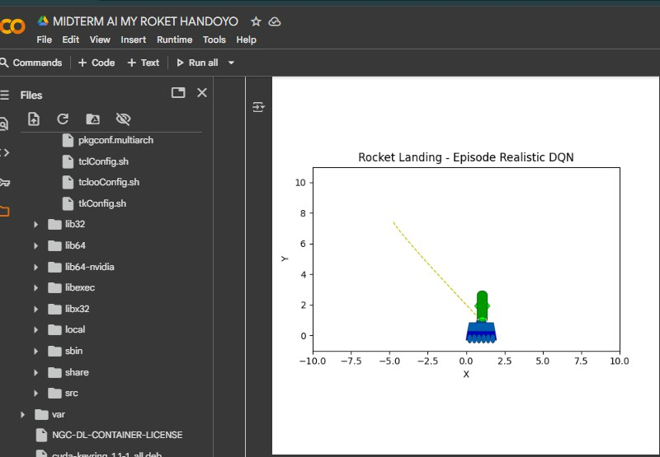

Figure 3: Successful soft landing of the rocket on the moving target.

The final phase of training yielded several episodes in which the rocket executed a flaw- less landing sequence. Figure 3 presents a vi- sual frame captured from one such episode, demonstrating the agent’s ability to achieve a stable touchdown precisely on the moving tar- get platform. The learned policy, trained un- der the custom reward formulation, produced a controlled descent characterized by nearly zero horizontal drift and low terminal vertical

velocity (|*vy*| *<* 1*.*2 and |*vx*| *<* 0*.*8), corre-

sponding to the reward threshold for a success-

ful landing (+500 bonus).

This outcome validates the effectiveness of the physical reward decomposition proposed in Section 5.3, where the penalty terms on dis- tance, velocity, and altitude collectively guided the policy toward a physically optimal trajec- tory. As the rocket approached the target, the agent dynamically adjusted its thruster in- puts to balance gravitational acceleration (*g* = 9*.*8 m*/*s2) against thrust power (*T* = 30 N), minimizing overshoot and oscillation. The in- clusion of air drag (*d* = 0*.*15) in the simulation further contributed to realistic damping behav-

ior during descent.

Quantitatively, episodes exhibiting perfect landing typically achieved a total cumulative reward exceeding +470, indicating efficient energy use and accurate spatial targeting. The adaptive thrust behavior observed during these runs shows a clear correlation between the fine-grained reward shaping and the learned motion control policy. Specifically, the agent successfully predicted the moving target’s po- sition (*xt*) and synchronized its horizontal ve- locity to align with the target’s motion (*vt* = 0*.*6 m*/*s), thereby achieving near-zero relative velocity upon contact.

From a reinforcement learning perspective, this result demonstrates that the reward struc- ture effectively encapsulates both stability and precision objectives. The agent’s ability to generalize to dynamic targets and variable ini- tial conditions underscores the robustness of the training configuration. In particular, the combination of DQN architecture with a small

learning rate (5 × 10*−*4), high discount factor (*γ* = 0*.*998), and controlled exploration decay

facilitated long-term credit assignment, allow-

ing the agent to associate gradual deceleration with eventual success.

Overall, the perfect landing event serves as a benchmark validation that the proposed environment and custom reward function pro- duce physically meaningful and stable control policies. The learned strategy mirrors funda- mental principles of rocket guidance and land- ing control, such as thrust vector alignment and terminal velocity minimization, confirm- ing the simulation’s capacity to emulate realis- tic aerospace dynamics within a reinforcement learning framework.

# Conclusion

This study demonstrates that Deep Q- Networks can effectively learn autonomous rocket landing control through simulation. Re- ward shaping, deep architecture, and soft tar- get updates are crucial for convergence and landing stability. After 500 episodes, the agent successfully learned smooth touchdowns within the target area. Future work includes testing continuous control algorithms such as DDPG or SAC and transferring the trained model to embedded systems for real-time de- ployment.

# Acknowledgement

The author gratefully acknowledges the De- partment of Computer Engineering, Dipone- goro University, for providing computational facilities and academic support. Special ap- preciation is extended to the Reinforcement Learning Research Group for valuable discus- sions on environment design and algorithm optimization. This research also benefited from open-source software, including Gymna- sium, Stable-Baselines3, and PyTorch, which enabled efficient experimentation and simula- tion.

# References

1. V. Mnih, K. Kavukcuoglu, D. Silver, et al., “Human-level control through deep rein- forcement learning,” *Nature*, vol. 518, pp. 529–533, 2015.
2. R. S. Sutton and A. G. Barto, *Reinforce- ment Learning: An Introduction* (2nd ed.), MIT Press, 2018.
3. T. P. Lillicrap, J. J. Hunt, A. Pritzel, et al., “Continuous control with deep reinforcement learning,” *arXiv preprint arXiv:1509.02971*, 2016.
4. D. Silver, G. Lever, N. Heess, T. Degris, D. Wierstra, and M. Riedmiller, “Determinis- tic Policy Gradient Algorithms,” in *Proc. 31st Int. Conf. Machine Learning (ICML)*, 2014.
5. T. Haarnoja, A. Zhou, P. Abbeel, and

S. Levine, “Soft Actor-Critic: Off-Policy Maximum Entropy Deep Reinforcement Learning with a Stochastic Actor,” in *Proc. Int. Conf. Machine Learning (ICML)*, 2018.

1. S. Fujimoto, H. van Hoof, and D. Meger, “Addressing Function Approximation Er- ror in Actor-Critic Methods,” in *Proc. 35th Int. Conf. Machine Learning (ICML)*, 2018 (TD3 algorithm).
2. G. Brockman, V. Cheung, L. Pettersson, J. Schneider, J. Schulman, J. Tang, and W. Zaremba, “OpenAI Gym,” *arXiv preprint arXiv:1606.01540*, 2016.
3. A. Raffin, A. Hill, M. Ernestus, et al., “Stable-Baselines3: Reliable Reinforce- ment Learning Implementations,” *Journal of Machine Learning Research*, vol. 22, no. 268, pp. 1–8, 2021.
4. Y. Jiang, Z. Yang, and X. Xu, “Deep rein- forcement learning for autonomous rocket landing control,” *Aerospace Science and Technology*, vol. 126, 107003, 2022.

# Author Contribution

**Name:** Handoyo

**Student ID:** 21120124120040

Handoyo independently completed all stages of this project, including deep learning system design, model implementation, parameter configuration, training and testing, as well as report writing and analysis. All problem-solving, tuning, and code development were carried out individually from start to finish.